Workshop on Protect Girl child & promote adoptions
REPORT
The seminar was organized by Deep Welfare Organisation (N.G.O.) This half daylong seminar was organized on 27th October 2016 at Constitution Club of India, Rafi Marg, New Delhi. This seminar was supported by, Union Bank of India, Hindustan Petroleum, AS Resources, Vijayam Infra Solutions, Chintan Publications and our Media Partner was Panchayat Khabar
The registration process of participants started at 01:30 pm. The registration process was coordinated by Mr. Shashi Bhusan and Mrs. Manju Sutwal. An educational kit was provided to all the participants after registration.
Inaugural Session:
- The seminar started at 02:00 pm. Ms. Vibha Pandey was hosting on the dais as anchor. After the introductory talks Smt. Sushma Sahu, Member, National Commission for Women, Mr. Vikram datt, Senior Social Activist, Mr. S.K. Datta, Media Analist, Dr. Uma Aggarwal, Retd. Medical Professional, Mr. M.M. Vidhyarthi, General Secretary, Samarth, Mr. Prabodh Kumar, Senior advocate, Supreme Court were invited on dais in Inaugural session. Mr. Ajay Prakash (Secretary, Deep Welfare Organisation) welcomed the guests by presenting them boquets. Then welcome song was presented by Ms. Sonia, Mrs. Shail, Ms. Ruchi in the honour of all guests and participants. Welcome song was followed by the introductory speech by secretary of Deep Welfare Organisation, Mr. Ajay Prakash. Mr. Ajay Prakash focused on the relevance of the month for organizing such an event. October month were Navratra was celebrated all over the country to were Maa Durga is worshipped and women power is celebrated. In October International Girl Child day is also celebrated worldwide. Mr. Prakash had thrown light on the situation of the girl child in India and focused on adoptions of girl child as need of the hour.

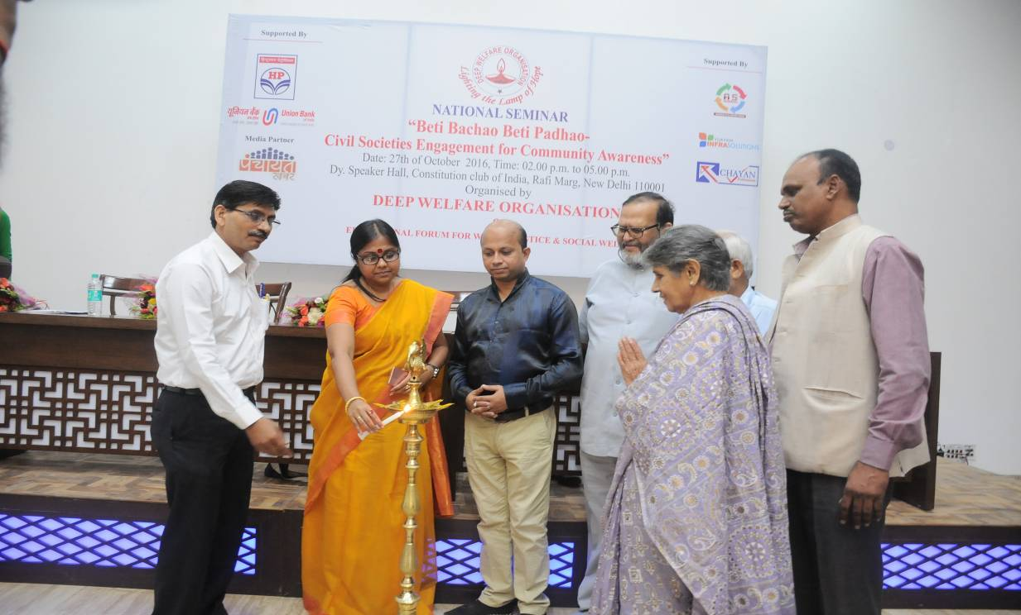
After the inaugural of seminar by lighting the lamp Mrs. Sushma Sahu was invited to give her presidential speech. First of all Mrs. Sahu appreciated Deep Welfare Organisation for its activities and community work. Mrs. Sahu told that girls shoud be properly educated to overcome the current situation and she also sought the help from the family members to support their daughter to make them self ready to face any challenges and confident. Support from family and society is very important factor which will strengthen the girls to thrive in every aspect of their life. She also gave some examples as a role model where women’s outperformed in her career, education and business apart from the odd situations she had. She again appreciated Deep Welfare Organisatin and focused on the relevance of the day for this workshop. She Lastly, again thanked Deep Welfare Organisation for its initiatives and work.
Dr. Uma Aggarwal shared her views after Mrs. Shushma Sahu, she focused on insecurity in human beings minds about their old age and other wise. This insecurity leads to demand of male child instead of female child. She also told about lord Shiva Ardhnarieshwar. Shee told that all men have half male hormones and half female hormones. So they are impure. Only females are pure because they have 100 percent female hormones. This is the reason that in case of any crisis or problem, we remember females to help us. He told that the ratio of girl child is becoming lesser and lesser because we are not accepting the natural process. She concluded that we should not play with nature.
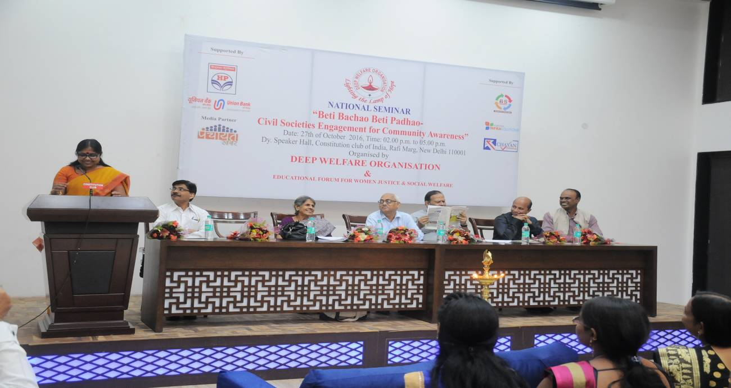

Session-II
The theme of the Second session was ‘Status of girl child in India’. Dr. Bijaya Laxmi Nanda (Prof., Miranda House, University of Delhi), Mr. M.M. Vidyarthi (Member, DCPCR), were the experts in session-II.
First of all Dr. Nanda was invited on Dais to share her thoughts and expert views on the topic. Dr. Nanda showed her concerns about Unsuccessful efforts to save girl child. She raised a question as how to make it a success. She also focused on adoption and specially focused on girl child adoption. She told about illegal sex detection going on in states like Delhi also which leads to female feticides.
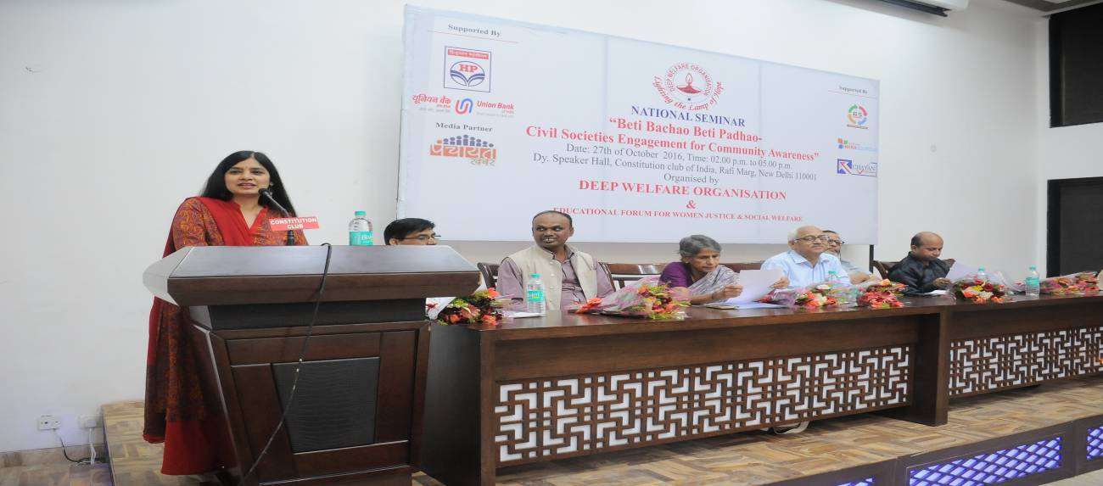
Dr. Nanda focused on declining sex ratio in India, especially in Delhi. She compared the situation in urban areas and rural areas also. She presented state wise data of declining sex ratio where she compared situation of 1991 and 2011.
Session-III
The theme of 2nd session was “Importance of PCPNDT Act”. Mr. Prabodh Kumar, Sr. Advocate Supreme Court was the experts in the second session.
Mr. Prabodh Kumar, praised Dr. laxmi Nanda for her beautiful speech in the previous session. He focused on poor child ratio in India and told about some socio-cultural factors and religious for the same. He told about PCPNDT Act.
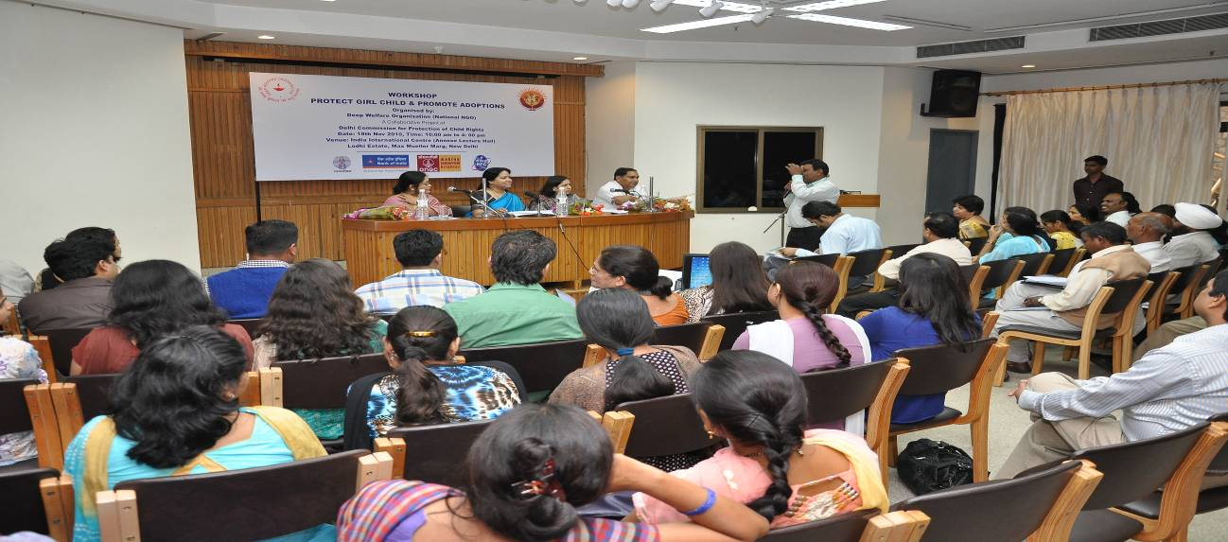
he raised a question that he has been talking on this issue from last five years and for how long he will have to talk, for the changes to come?. He told that worst affected states are Punjab, Haryana, Delhi, and Gujarat. She told that India had lost over 10 million girls because of female feticide in last 20 years.
Session-IV
The theme of session IV was ‘Role of stake holders for protection of Girl child’. Mr. S.K. Datta, Media Analist, Mr. Ashok Srivastava, Sr. Anchor, DD News, Mr. M.M. Vidhyarthi, General Secretary, Samarth were the experts in the session.
Mr. S.K. Datta shared his views and told that the topic is very important and relevant for the time and it is the need of the hour. He shared his concern on decreasing sex ratio. He gave example of farmers that farmers want male child instead of female child because male child would help them in farming and irrigation. He suggested forming tractor co-operatives for farmers. He was concerned on the dowry system in our country. Mr. Datta told that because of dowry system people does not prefer girl child. He told that girl child care more for parents than male child. Mr. Datta also remembered Olympics where three medals were won by females. And that too from state like Haryana where sex ratio is very less.
Mr. M.M. Vidyarthi focused on adoption. He told that in one year approximately 20 female child use to be thrown out in streets near AIIMS immediately after birth. He told the role of DCPCR in those cases and how DCPCR is working to keep these things under control. He also appealed to the participants to ask questions to the speakers.
Mr. Ashok Srivastav, told the participants the difference we all can make by uniting on such issues. He also stressed on social support which is an unavoidable condition for overall improvement in the situation of girl child. He also said that women could do wonders with less support but if she is supported well then we can’t calculate the outcome.
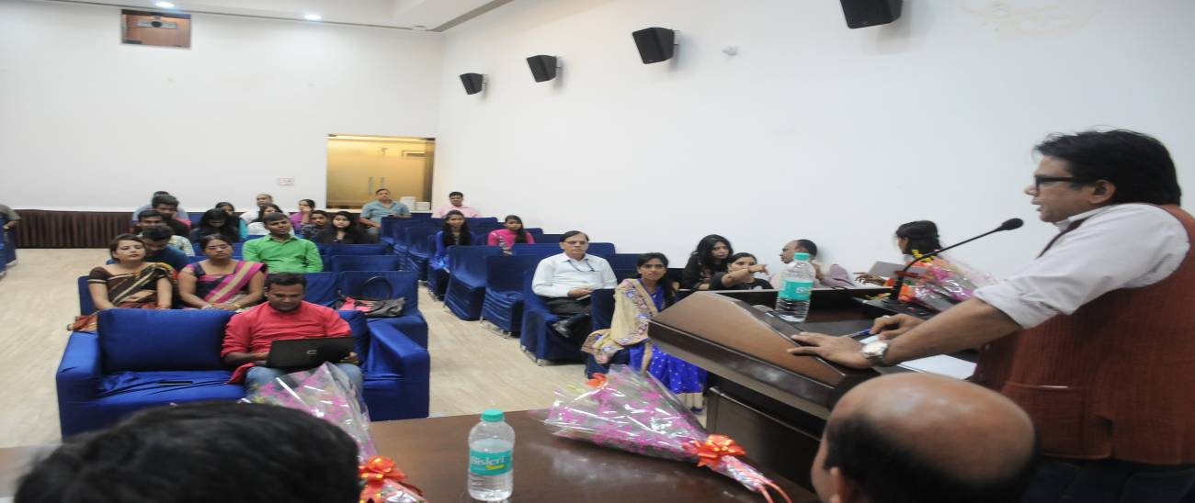
Vote of Thanks
Vote of thanks to all the guest & participants has been provided by Mr. Ajay Prakash (Secretary, Deep Welfare Organization).

