Report of EDP training

Project: Vocational Training for Youth in Vulnerable Condition in Jharoda, Wazirabad, Sangam Vihar, Delhi-110084.
Venue: Training Centre, Computer
No. of Participants: 16
Dated: 26/12/2014 to 30/12/2014

Resource Persons:
- Shri. Ajay Prakash
- Ms. Priyanka
- Ms. Shristi Gupta
- Mr. Akhilesh kumar Prajapati

EDP training was organized by Deep Welfare Organization under FVTRS Project. The Aim of Training was to give soft skill training to all the participants.

In the five day training program, the topics which were covered are
- Identity and Background
- HIV/AIDS awareness
- Communication Skills
- Self-Esteem
- Goals and Expectations, etc.

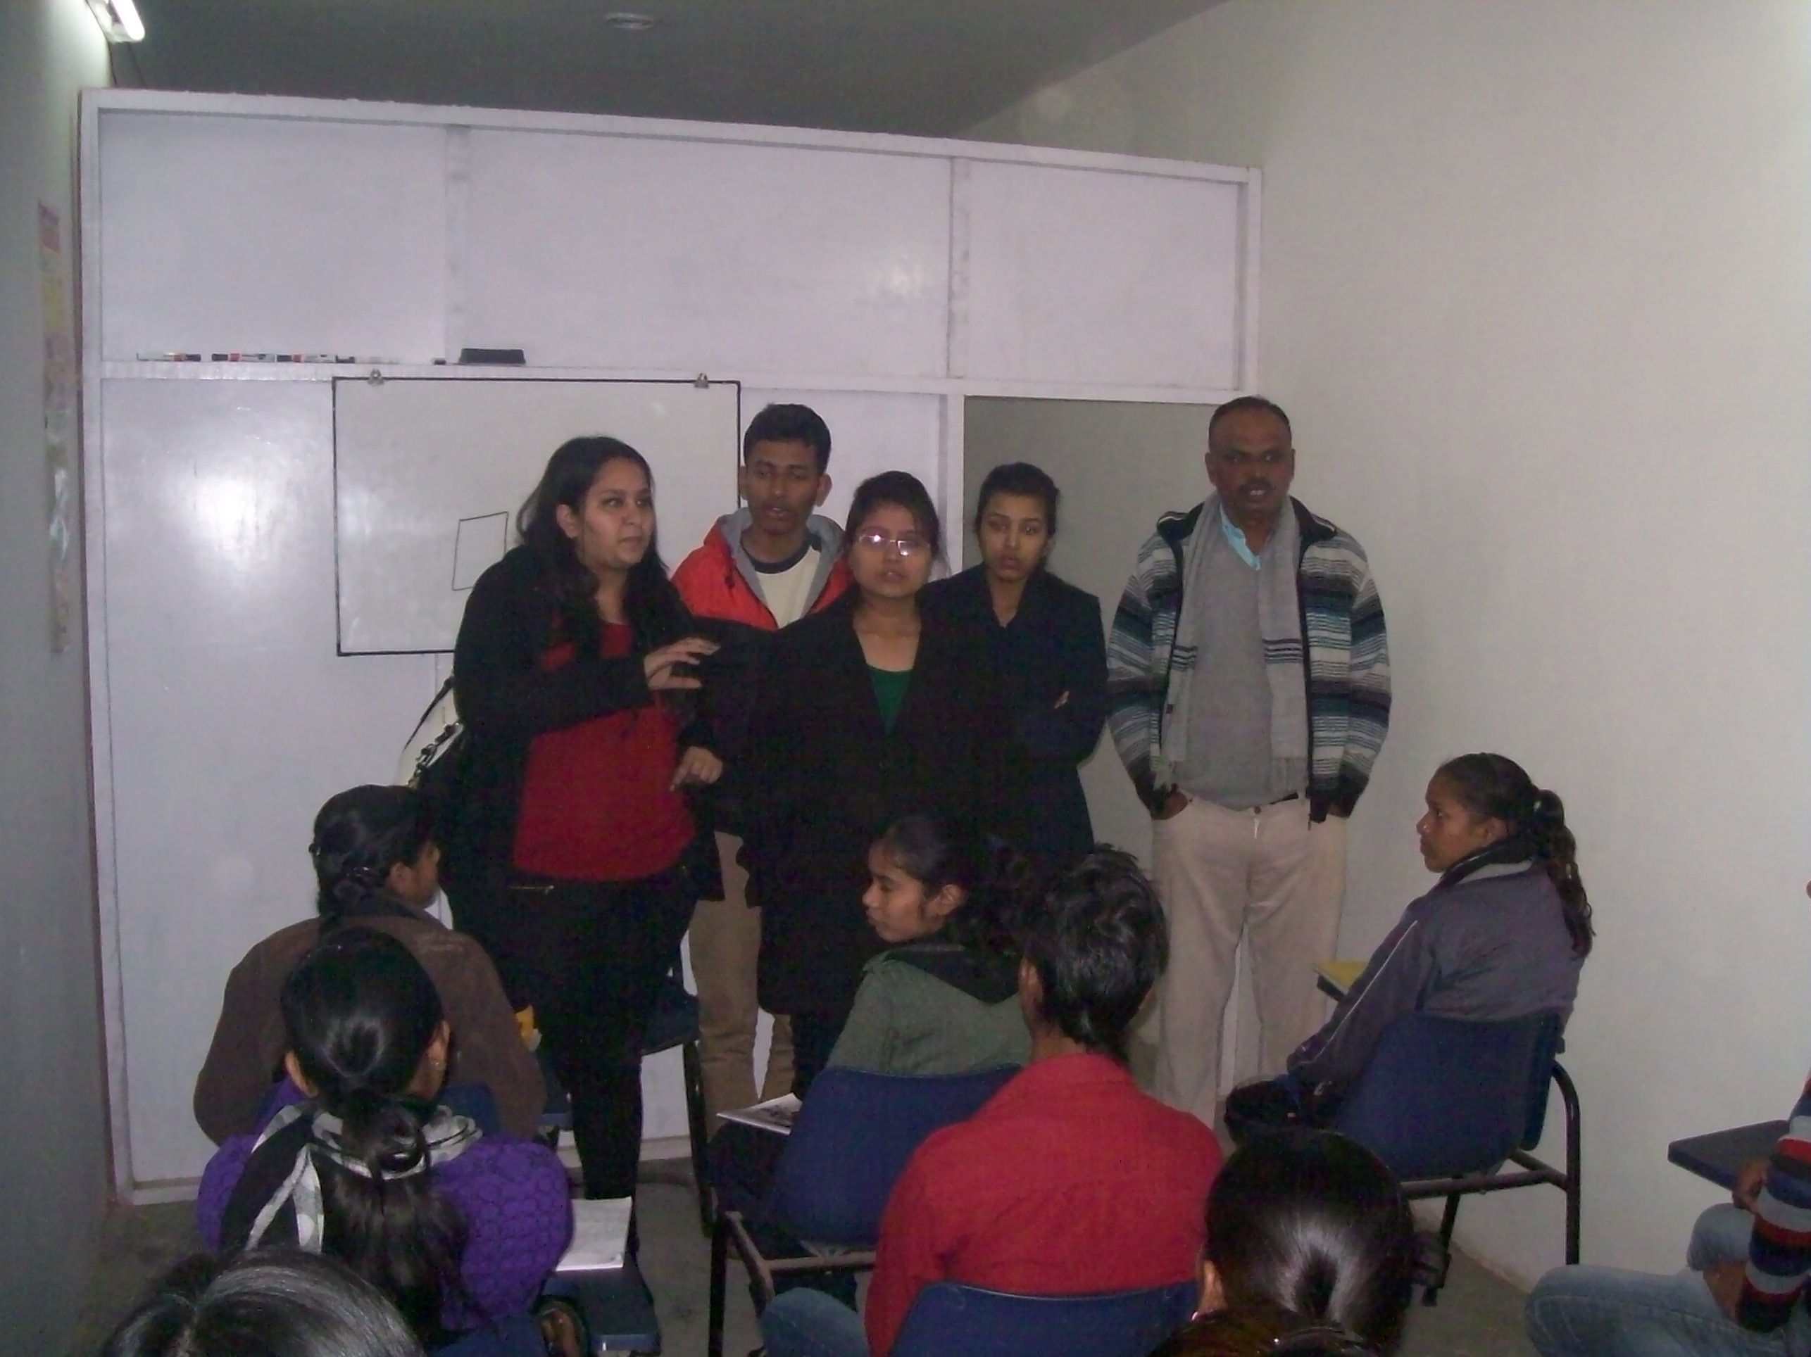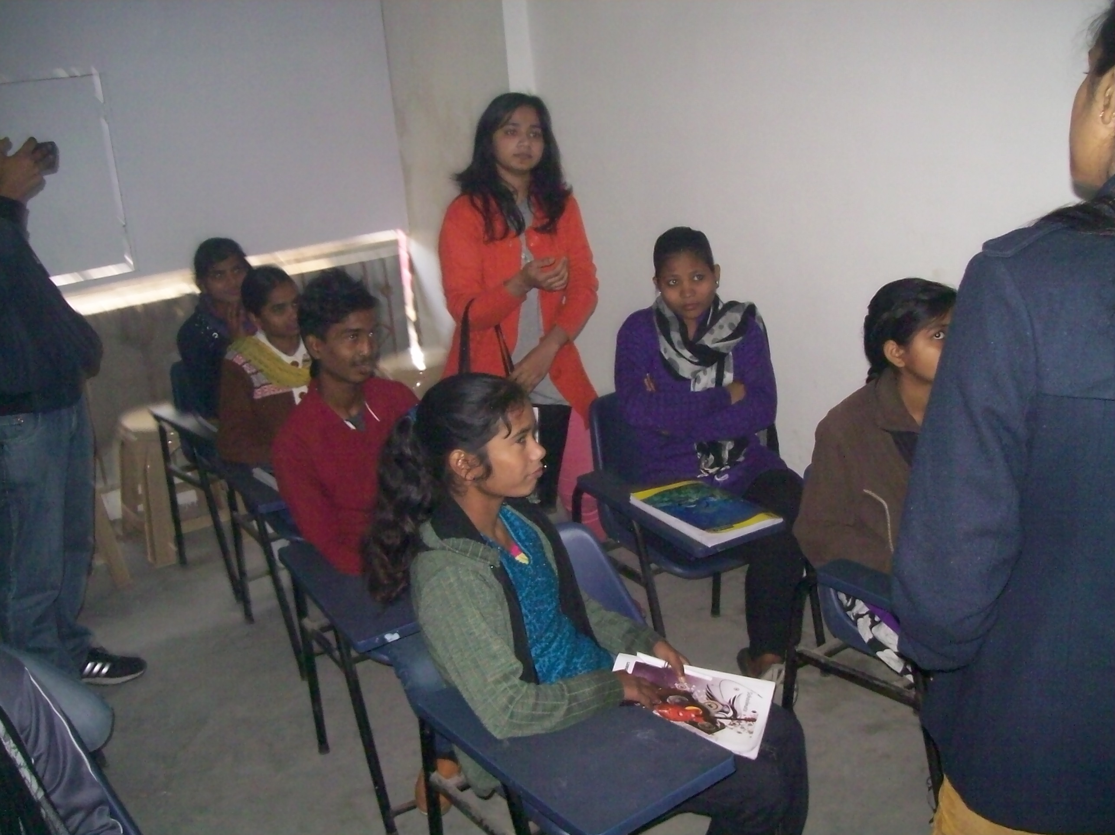

- The purpose of life skills education is to:

- Reinforce existing
- Identity

- Prevent or reduce
- Myths & misinformation, negative
attitudes, risky behaviors

- Understanding & developing personal competencies by goals, expectations, self-esteem.
- Social & interpersonal skills includes; Gender, Values & Perception, balancing relationship, decision making, HIV Aids awareness.
- Communication Skills including listening skills and body language.
- Managing Situations by conflict resolutions, time management, money management, handling responsibilities
- Explain entrepreneurship, its characteristics and importance
- Explain the factors that affect the development of entrepreneurship such as environment, financial issues, society and government
- Soft skills required
- Identification of business opportunities
- Linkages with financial institutions
- Forward and Backward linkages
- Tools for market survey – Market perception; Market intelligence and marketing strategy
- Knowledge of applicable local laws, rules and regulations
- Management resources – Men, Material and Finance
- Appropriate machinery/tools and the sources of their availability
- Making project presentations and other related issues

Awareness about the HIV/AIDS and other health issues as follows:
Health awareness: During this training awareness was created on various health aspects, such as:
- How to prevent HIV/AIDS.

In addition to above, the beneficiaries were informed about HIV/AIDS, how it spreads, its causes, and its harmful effects. Some misconceptions about this disease were also cleared during this training. The beneficiaries were informed about the various precautionary and preventive measures against HIV/AIDS to ensure a healthy and happy living.

Five day training program was concluded by vote of thanks by Shri. Ajay Prakash.

