CASE - STUDY

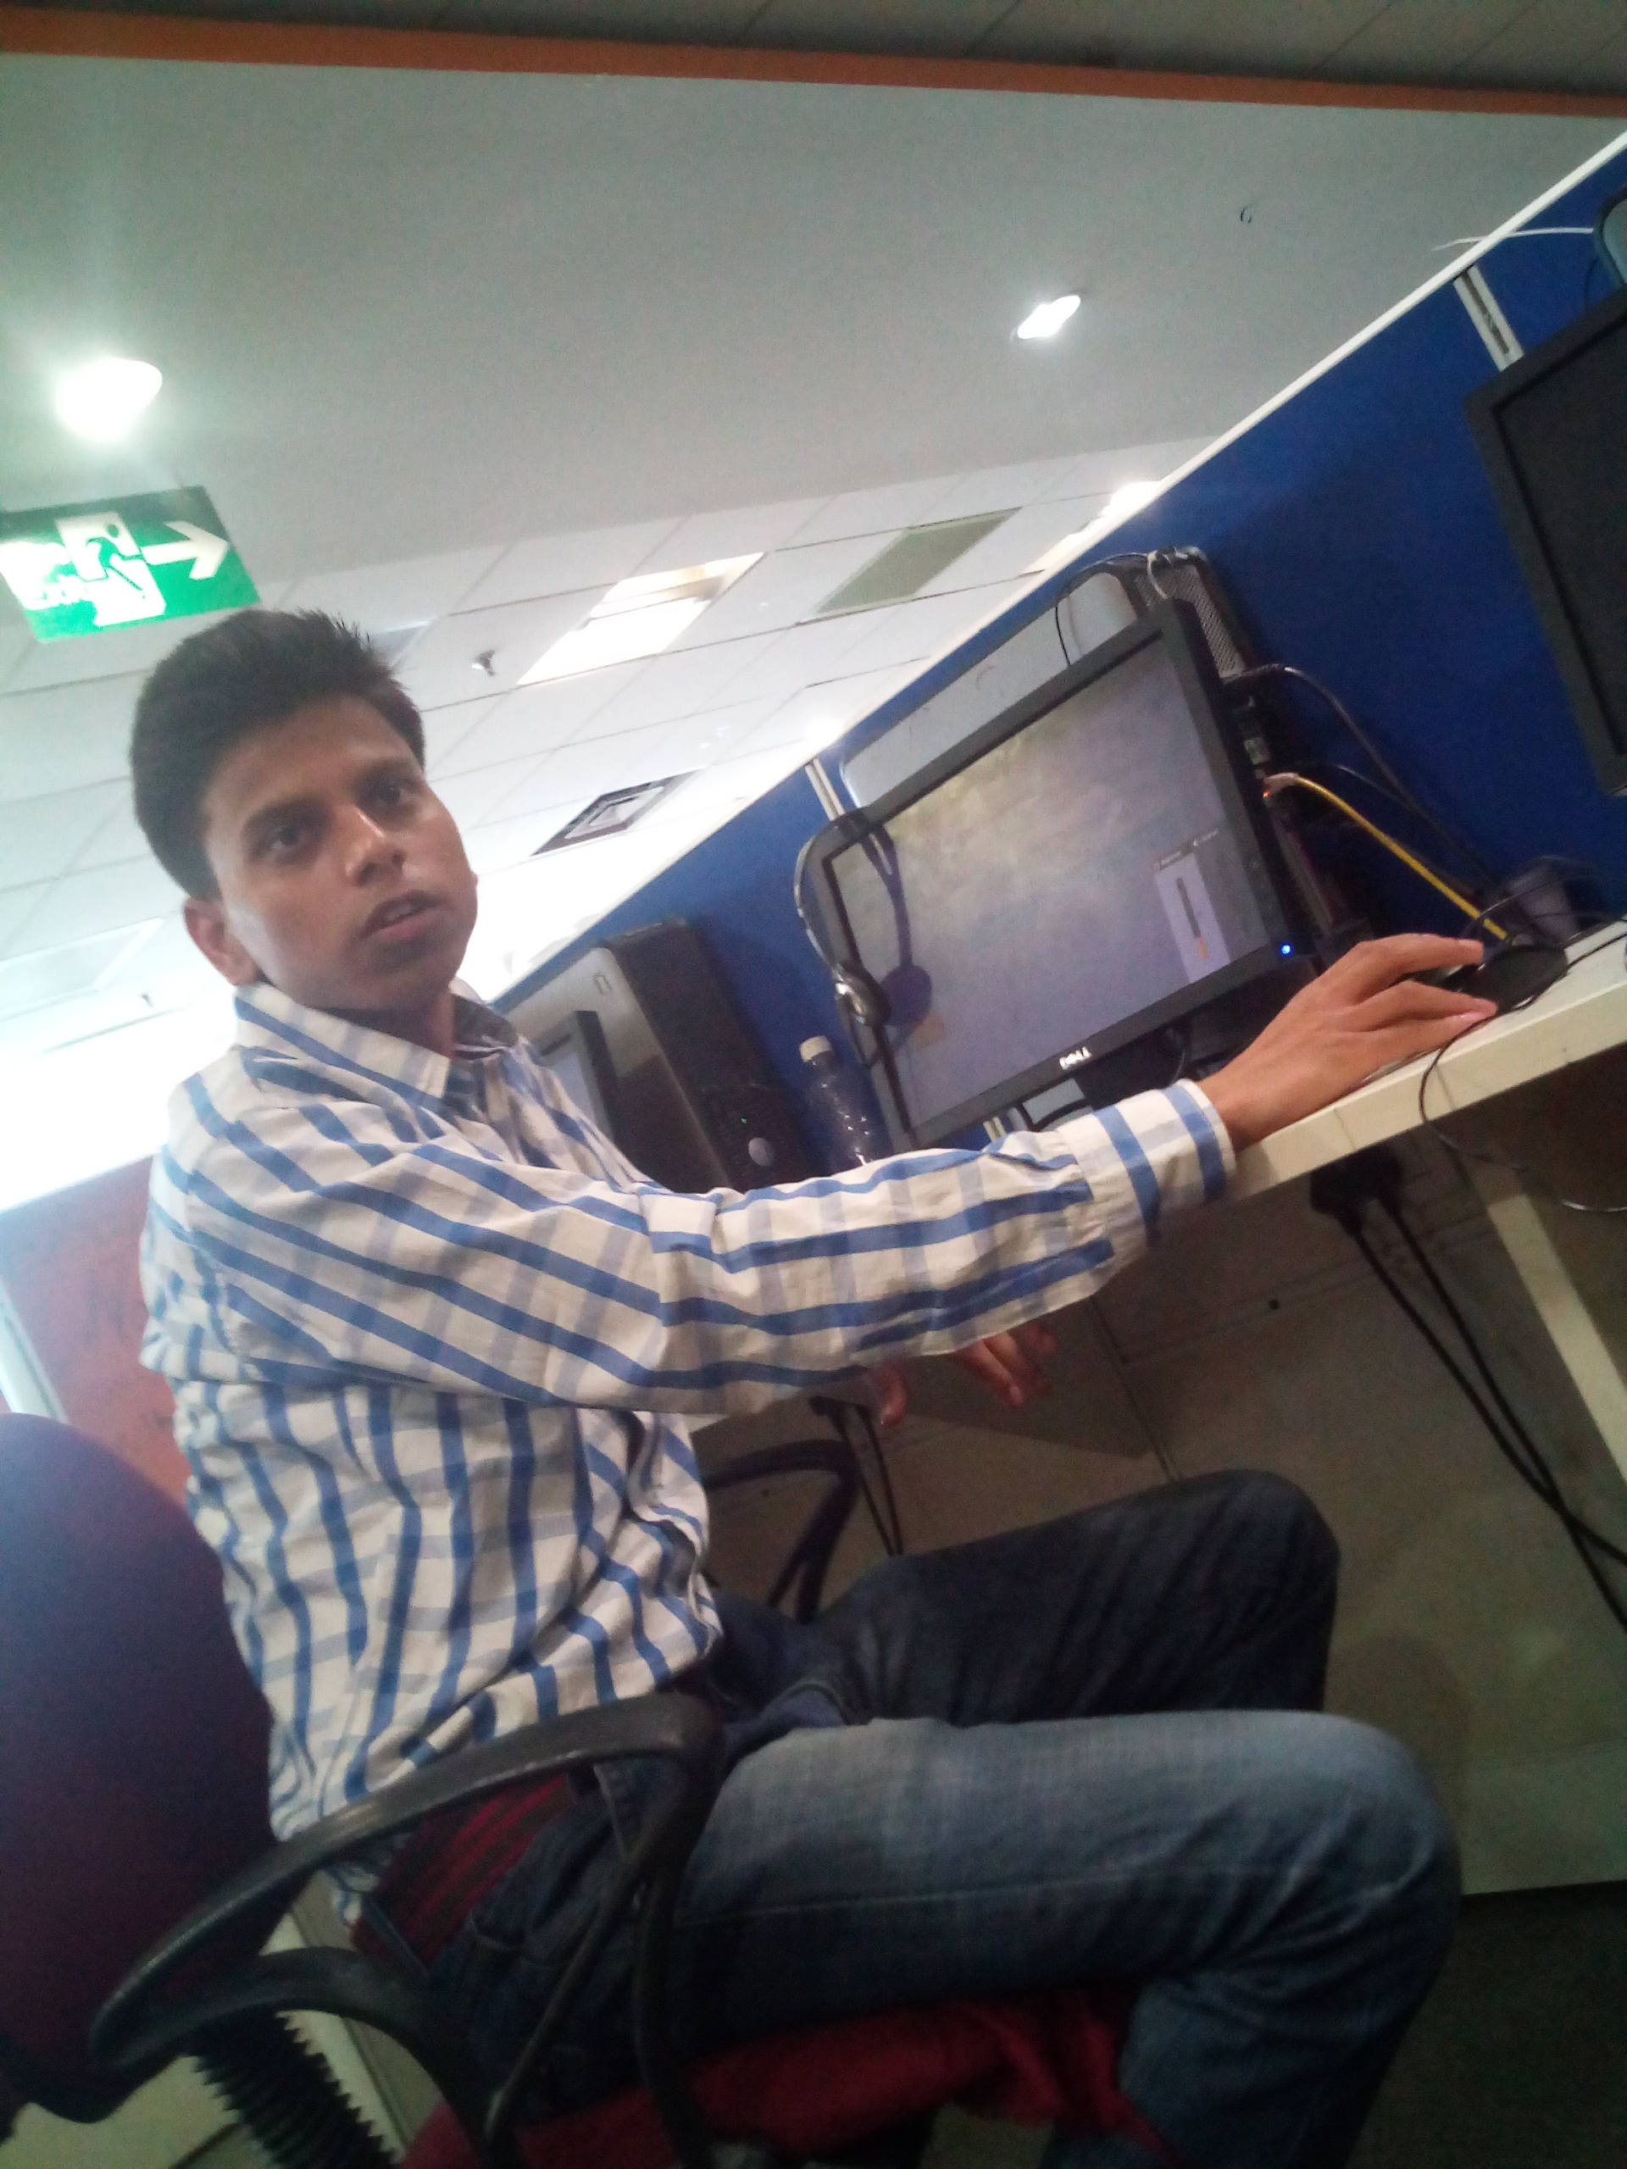

Name- Navneet Singh, Age 20, is a resident of Gali No. 2, Jharoda Part-1, Delhi where the project of Training for Youth in Vulnerable Condition from FVTRS is being implemented by Deep Welfare Organization. He is drop out from school due to poverty. His father is unemployed. There is no earning member in the family no are is there to support the children for education. He has attended course on Computer. Her performance was very good during the training program also. Now, He is an entrepreneur. He was selected for the job in a reputed call centre in Noida. He earns Rs. 7000 per month.

