CASE - STUDY

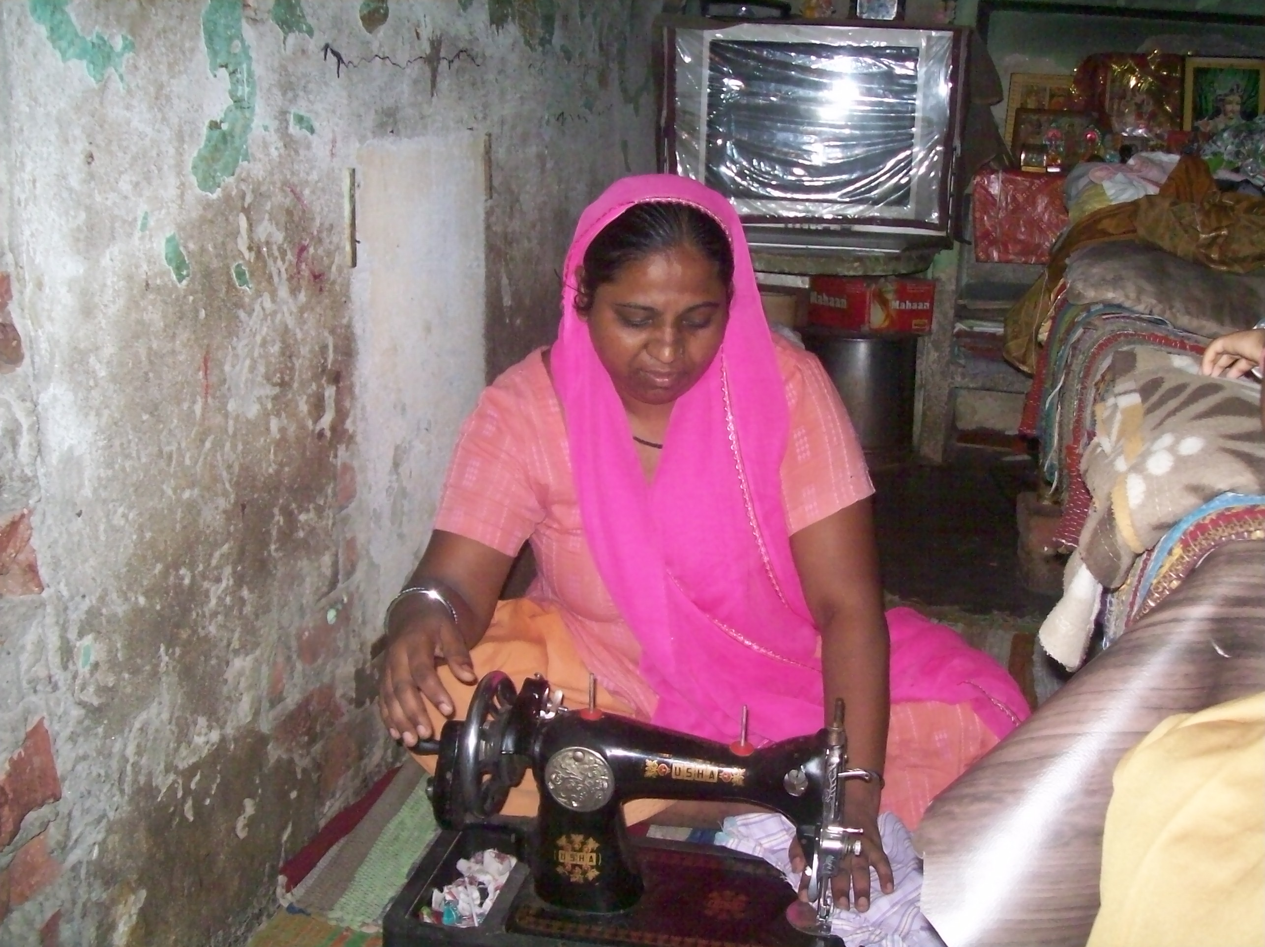

Name Anita Devi, Age 32, is a resident of Gali No. 4, Sangam Vihar, Delhi where the project of Training for Youth in Vulnerable Condition from FVTRS is being implemented by Deep Welfare Organization. She is drop out from school due to poverty. She has attended course on Dress Making. Her performance was good during the training program also. Now, Anita Devi is an entrepreneur. She does work at home only. She earns Rs. 2500-3000 per month on an average.

