CASE - STUDY

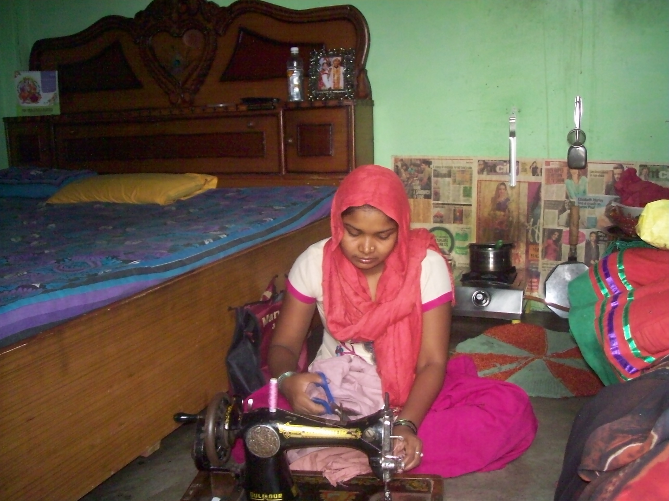

Name Seema Devi, Age 23, is a resident of Gali No. 4, Sangam Vihar, Delhi where the project of Training for Youth in Vulnerable Condition from FVTRS is being implemented by Deep Welfare Organization. Her husband is a labour in a garment factory miserable. She is drop out from school due to poverty. She has attended course on Dress Making. Her performance was excellent during the training program also. Now, She is an entrepreneur. She does the job-work at her home only and she earns Rs. 2500-3000 per month.

