CASE - STUDY

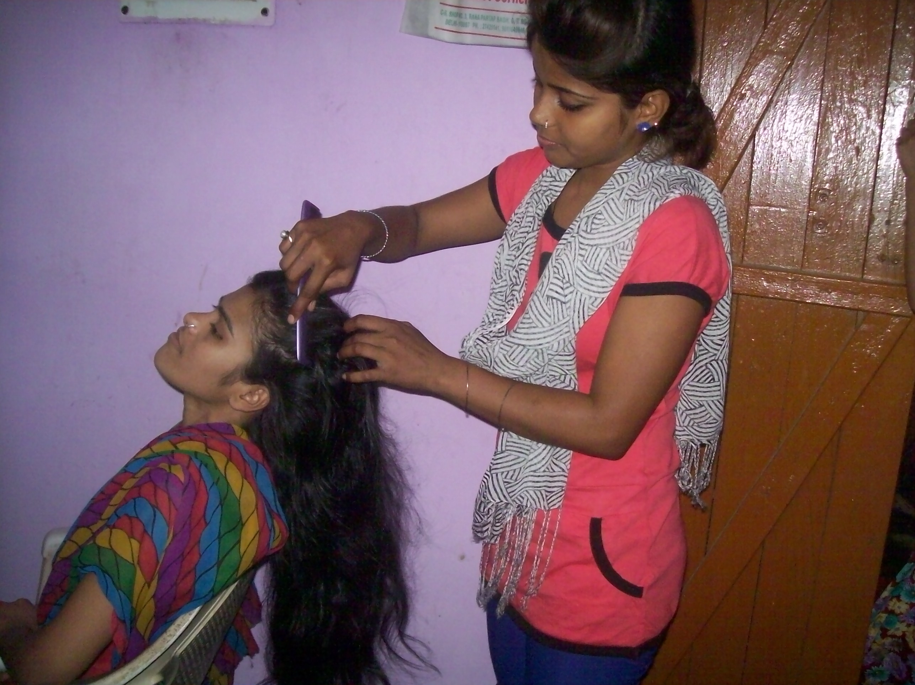

Name- Shakuntala, Age 20, is a resident of Gali No. 11, Jharoda Part-2, Delhi, near to the place where the project of Training for Youth in Vulnerable Condition from FVTRS is being implemented by Deep Welfare Organization. She is drop out from school due to poverty. Her father is a fourth class employee. Her family economic condition is very bad She has attended course on Beauty Culture. Her performance was very good during the training program also. Now, Shakuntala is an entrepreneur. She does the job-work and her performance in the field is said to be excellent. She earns Rs. 3000-4000 per month on an average.

